Name: R . Sharmila
Course code: CSA0606
Course name: Design and Analysis and Algorithms
Reg no:192521213
Branch: Bect(IT)
Slot: B

Tilte
university result comparison system using pairwise comparison

Q72. Application: University Result Comparison System A result analysis system compares each student's score with every other student's score to prepare rank statistics. Recall what pairwise comparison implies in complexity analysis, explain why execution time increases rapidly, and compute both the time complexity and space complexity using asymptotic notation.

Introduction
Educational institutions process the examination results of hundreds or even thousands of students every semester. One of the important tasks performed after publishing results is preparing rank lists and analyzing student performance. To generate these statistics, the marks of one student are often compared with the marks of every other student. This method is known as pairwise comparison.
Pairwise comparison is widely used in ranking systems because it allows accurate comparison between every pair of students. For example, if there are five students, the system compares Student 1 with Students 2, 3, 4, and 5. Then Student 2 is compared with Students 3, 4, and 5, and so on until every possible comparison has been completed.
Although this method provides complete comparison results, the number of comparisons increases rapidly as the number of students increases. Therefore, understanding the computational complexity of pairwise comparison is very important. In this experiment, the algorithm is implemented in C and its performance is analyzed using asymptotic notation.

Problem Statement
A University Result Analysis System compares every student's score with every other student's score to prepare rank statistics. Recall what pairwise comparison implies in complexity analysis, explain why the execution time increases rapidly, and determine both the time complexity and space complexity using asymptotic notation.

Objectives
The objectives of this experiment are:
- To understand the concept of pairwise comparison.
- To implement a student result comparison system using C.
- To compare every student's marks with every other student's marks.
- To analyze the algorithm using asymptotic notation.
- To determine the time complexity and space complexity.
- To understand how execution time changes with increasing input size.

Theory
Pairwise comparison means comparing every element with every other element exactly once. In this problem, each student's marks are compared with all remaining students to prepare ranking information.
If there are n students, then every student participates in multiple comparisons. The total number of comparisons is:
$$\frac{n(n-1)}{2}$$
This formula shows that the number of comparisons increases very quickly as n becomes larger.

Implementation
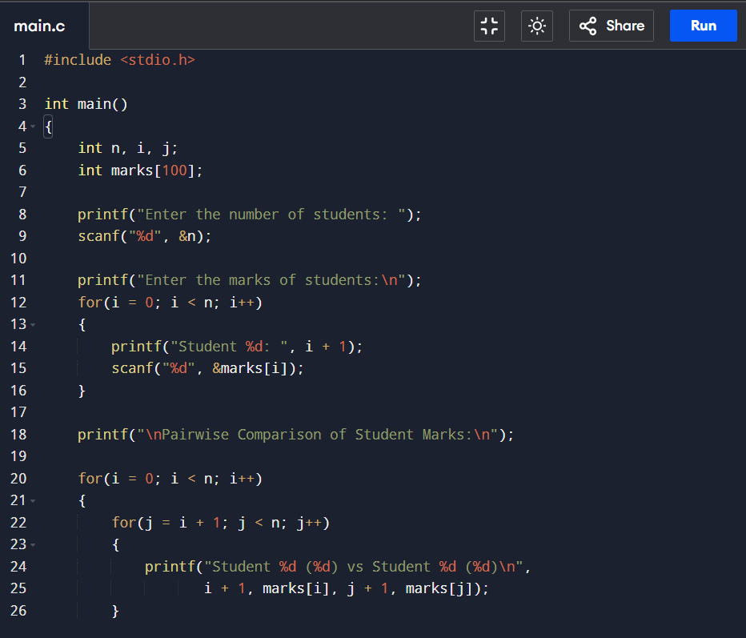

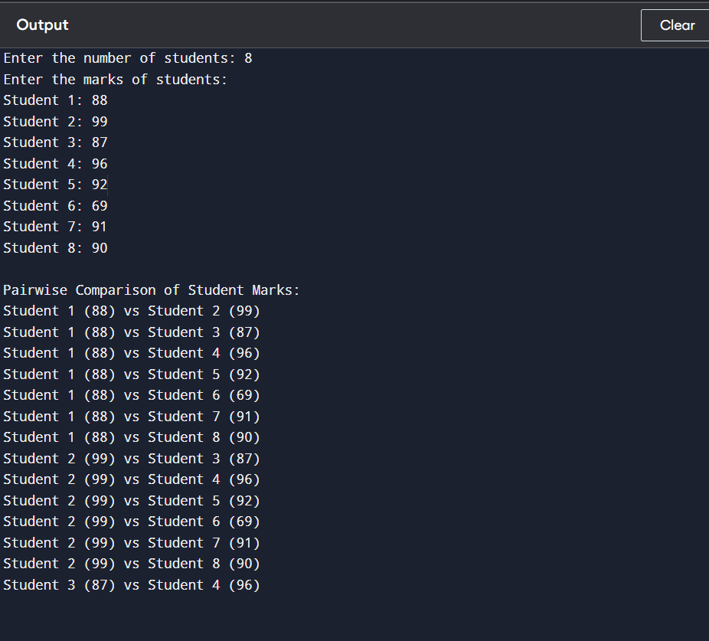

Complexity Analysis
The algorithm uses two nested loops.
The outer loop executes n times.
For every iteration of the outer loop, the inner loop compares the current student with all remaining students.
Therefore, the total number of operations becomes:
$$n+(n-1)+(n-2)+⋯+1$$
which simplifies to:
$$\frac{n(n-1)}{2}$$
Ignoring constants and lower-order terms:
$$T(n)=O(n^{2})$$
Hence,

Time Complexity = Θ(n²)
The program stores student marks in a one-dimensional array of size n.
Therefore,
Space Complexity = O(n)

Why Execution Time Increases Rapidly
The execution time increases rapidly because every student's score is compared with every other student's score. When the number of students doubles, the number of comparisons becomes approximately four times larger.
For example:
- 10 students → 45 comparisons
- 20 students → 190 comparisons
- 50 students → 1225 comparisons
- 100 students → 4950 comparisons
This quadratic growth makes pairwise comparison slower for large datasets.
Asymptotic Notation
Big-O Notation
$$O(n^{2})$$
This represents the maximum running time of the algorithm.
Big-Omega Notation
$$Ω(n^{2})$$
This represents the minimum running time.

Big-Theta Notation
$$Θ(n^{2})$$
This represents the exact running time because the algorithm always performs pairwise comparisons.

Conclusion
In this experiment, a University Result Comparison System was designed and implemented using nested loops in C programming. The system successfully compared every student's marks with every other student's marks, demonstrating the concept of pairwise comparison. The analysis showed that the algorithm performs approximately n(n−1)/2 comparisons, resulting in a Θ(n²) time complexity and O(n) space complexity. The experiment also highlighted that while pairwise comparison provides accurate ranking information, its execution time increases rapidly as the number of students grows. Therefore, it is suitable for small and medium-sized datasets but may require optimization for large-scale university result processing systems.

References
- Thomas H. Cormen, Charles E. Leiserson, Ronald L. Rivest, and Clifford Stein, Introduction to Algorithms, 4th Edition, MIT Press.
- Ellis Horowitz, Sartaj Sahni, and Susan Anderson-Freed, Fundamentals of Data Structures in C.
- Alfred V. Aho, John E. Hopcroft, and Jeffrey D. Ullman, The Design and Analysis of Computer Algorithms.
- Course notes and lecture materials on Design and Analysis of Algorithms.

